Association Relationship

Example 1:
How many objects we get from the following UI?

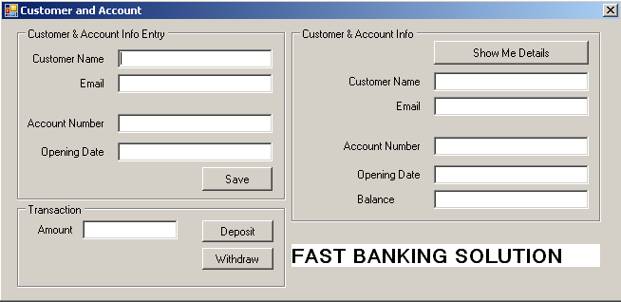

Yes, we get here two domain objects: Customer and Account.

Customer
has name, email address.
On the other hand, Account
has account number, balance and opening date.
Also deposit and withdraw are the functionality of it.

Is there any relationship between Account and Customer object?
Yes, Customer has an account i.e. Customer has a relation with account type object and also we can tell Customer depends on Account. This type of relationship is called Association relationship (One-to-One).

Then how can implement this relationship in our code?

According to our findings, we can write our two classes as follows:

Account class:

public class Account
{
private string number;
private string openingDate;
private double balance;

public Account()
{
balance = 0;
}

public Account(string accountNumber, string openingDate) : this()
{
this.number = accountNumber;
this.openingDate = openingDate;
}

public string Number
{
get { return number; }
set { number = value; }
}

public string OpeningDate
{
get { return openingDate; }
set { openingDate = value; }
}

public double Balance
{
get { return balance; }
}

public bool Deposit(double amount)
{
balance = Balance + amount;
return true;
}

public bool Withdraw(double amount)
{
if (amount <= Balance)
{
balance = Balance - amount;
return true;
}
else
{
return false;
}
}
}

And Customer class:

public class Customer
{
private string name;
private string email;
private Account customerAccount = null;

public string Name
{
get { return name; }
set { name = value; }
}

public string Email
{
get { return email; }
set { email = value; }
}

public Account CustomerAccount
{
get { return customerAccount; }
set { customerAccount = value;}
}
}

Code of Save button click will be as follows:

private void saveButton_Click(object sender, EventArgs e)
{
customerObj = new Customer();
Account anAccount = new Account(accountNumberEntryTextBox.Text,
openingDateEntryTextBox.Text);
customerObj.Name = customerNameEntryTextBox.Text;
customerObj.Email = emailEntryTextBox.Text;
customerObj.CustomerAccount = anAccount;
MessageBox.Show(customerObj.Name + " has opened an account with " +
customerObj.CustomerAccount.Number + " number");
}

Customer type reference, customerObj has been declared after the definition of BankUI class so that other button click method can get access of it.

public partial class BankUI : Form
{
private Customer customerObj = null;

Code of Deposit button click as follows:

private void depositButton_Click(object sender, EventArgs e)
{
amount = Convert.ToDouble(amountTextBox.Text);
if (customerObj.CustomerAccount.Deposit(amount))
{
MessageBox.Show(amount + " Tk. has been deposited");
}
else
{
MessageBox.Show("Operation failed");
}
}

Code of Withdraw button click as follows:

private void withdrawButton_Click(object sender, EventArgs e)
{
amount = Convert.ToDouble(amountTextBox.Text);
if (customerObj.CustomerAccount.Withdraw(amount))
{
MessageBox.Show(amount + " Tk. has been withdrawn");
}
else
{
MessageBox.Show("Insufficient amount");
}
}

Code of ShowDetails button click as follows:

private void showDetailsButton_Click(object sender, EventArgs e)
{
customerNameDisplayTextBox.Text = customerObj.Name;
emailDisplayTextBox.Text = customerObj.Email;
accountNumberDisplayTextBox.Text = customerObj.CustomerAccount.Number;
openingDateDisplayTextBox.Text = customerObj.CustomerAccount.OpeningDate;
balanceTextBox.Text = customerObj.CustomerAccount.Balance.ToString();
}

See Code: SmallBank – Accociation Relationship in Solutions folder

Practice 1:

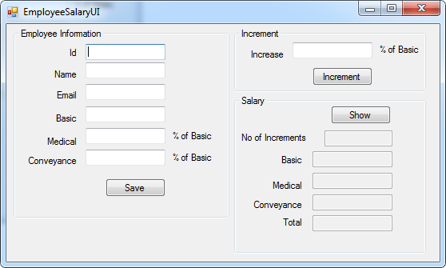

User will save employee information for one time only then will give increment to employee as many as (s)he wants.

Suppose, at first his salary is increased with 10% of Basic, then 5% of Basic, then 7% of Basic.

User presses Show button to see the updated salary information of the saved employee.

Run EmployeeSalary.exe from this location \3. OOP\3.1 Basic Concept\Practice.

Find the solution in \3. OOP\3.1 Basic Concept\Solutions\EmployeeSalary

Example 2:

One-to-Many Association relationship:

Consider the following application. User will enter department information and then (s)he will enter maximum 15 students under the saved department.

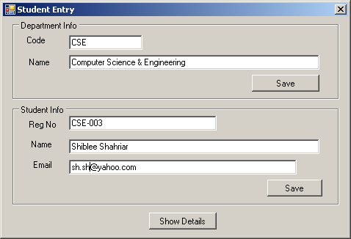

When Show Details is clicked, department and all saved information will be displayed in a MessageBox as following format.

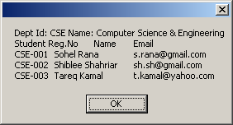

See the delivered solution.

Student class code:

public class Student
{
private string regNo;
private string name;
private string email;

public Student(string regNo, string name, string email)
{
this.regNo = regNo;
this.name = name;
this.email = email;
}

public string RegNo
{
get { return regNo; }
}

public string Email
{
get { return email; }
}

public string Name
{
get { return name; }
}
}

Department class code:

public class Department
{
private string code;
private string name;
private List<Student> studentList;
private const int MAX_NO_OF_STUDENTS = 10;

public Department(string code, string name) : this()
{
this.code = code;
this.name = name;
}

public Department()
{
studentList = new List<Student>();
}

public string Code
{
get { return code; }
}

public string Name
{
get { return name; }
}

public string AddStudent(Student studentObj)
{
if (studentList.Count <= MAX_NO_OF_STUDENTS)
{
studentList.Add(studentObj);
return "Student has been saved in dept.";
}
else
{
return "Maximum no of students (" + MAX_NO_OF_STUDENTS + ")
has been saved. So, provided student information is not
saved.";
}
}

public List<Student> GetStudentList()
{
return studentList;
}
}

See the full source code here: \3. OOP\3.1 Basic Concept\Examples & WalkThroughs\StudentDept

Practice 2: (on above example):

Update the code of above example so that Student Registration number will be unique. Find the solution here: \3. OOP\3.1 Basic Concept\Solutions\StudentDept

There’s an alternative solution in \3. OOP\3.1 Basic Concept\Solutions\StudentDept Using Dictionary, where Dictionary is used instead of List is a prefarable for this problem.

Practice 3: Make an application for Super Shop Store:

User will save the shop name and address initially. After that (s)he will save as many product as (s)he wants. If the product Id already exists, quantity will be updated instead of newly added. See UI:
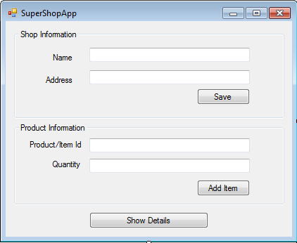

Example 3:

Now consider the following example:
This example is the upgrade version of previous one. Here, UI has several departments and each department has several students.

See the code: \3. OOP\3.1 Basic Concept\Examples & WalkThroughs\StudDeptUni

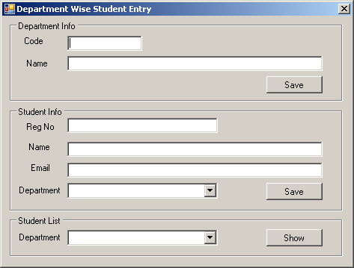

Practice 4 (on above example 3):

In the above example 3, you will see that student registration number is unique for department only. That means, registration number can duplicate if you consider the whole university. It’s a bug indeed. So, in this practice, you will ensure that registration number will be unique in university. It can’t be duplicated, no matter in which department (s) he is going for getting admission.
Find the solution here: \3. OOP\3.1 Basic Concept\Solutions\StudDeptUni

Practice 5:

It’s a new practice, which actually focuses on some previous examples and practices:

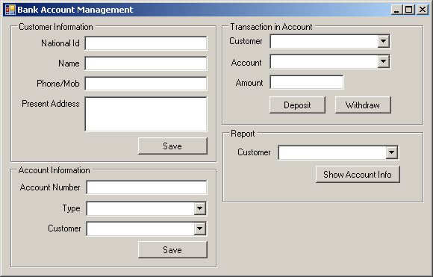

Condition:
A customer can hold one or more account. But there no option for joint account here. i.e. Account has only one customer.

National Id must be unique.
Account number must be unique.

Balance must be greater than or equals to zero for each type of bank account.

When Show Account Info has been clicked, information will be displayed in messagebox with same format.
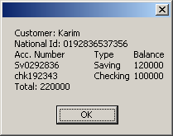
Find the solution here: \3. OOP\3.1 Basic Concept\Solutions\CustAccounts_One-To-many

Practice 6:

Make an Address book where user can keep many addresses (Person’s first name, last name, email, phone number). It is noted that email address will be unique and must has one ‘@’ and at least one ‘.’ character.

There will be a search option by last name (partial search), email, and mobile no (full search).

There should be an edit operation where user will find address by email and then edit any information (first name, last name, email, mobile number).

